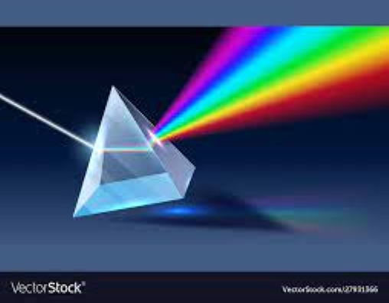

Spectral Forest
  - tEEm Radiance
Benjamin Reed, Hayden O’Reilly, Manolo Ortiz | Project Design Review
March 1, 2024

Table of Contents
Introduction 2
Problem Statement 2
Needs 2
Objective 3
Marketing Requirements 3
Concept 3
Project Management 7
Work Breakdown Structure 7
Gantt Chart 9
PERT Chart 11
Testing 12
Conclusion 16
References 17

Introduction
The health and diversity of plants in a forest can be determined by the condition of the forest, which can also serve as an indication of plant diseases and fire hazards. However, traditional methods of measuring forest health can be cumbersome, time-consuming, and require significant labor. While there have been previous efforts made to observe the health of the forest canopy, the understory is often overlooked. This highlights the need for a system that can evaluate forest health with minimal effort and waiting time.
Our project seeks to utilize the measurement of wavelengths of light in determining various conditions of the health and well-being of the forest understory such as plant health, species differentiation, and subtle environmental changes specific to the understory. While other spectrometers exist on the market that can be used in a more “local” setting and can measure light in similar ways, our design hopes to be able to run for extended periods of time within more remote locations. Our team consists of Benjamin Reed (Team Lead), Manolo Ortiz (Treasurer), and Hayden O’Reilly (Secretary), working alongside Dr. Alexander Shenkin.

Problem Statement
Needs The condition and diversity of plants can be determined by the health of the forest, which can be indicators of plant disease and fire dangers. Measuring the health of forests using traditional methods can be a tedious, time-consuming, and labor-intensive process. There is a need for a system that can evaluate the health of forests that are less labor-intensive with minimal waiting time.
Objective The objective of this project is to create and test a device capable of assessing the overall health of forests. The device will allow researchers to capture and save spectral image wavelengths that can be used to determine the well-being of plants and trees. With remote data-capturing capabilities, the device will eliminate the need for physical presence during data collection.

Marketing Requirements
The system should be portable, durable, and operate in a remote location for a long period of time. It should be easy to use and be able to collect, store, and extract data. In addition, the device should have the capability to measure the visible light spectrum and optimize power consumption.

Concept
The concept is a scientifically calibrated spectrometer, capable of observing and recording data from the light brought in from the forest. The system can run off 3 different power sources: Solar, USB, and Battery, and can automatically switch between them for optimal energy usage. The system design is centered around an optical assembly, which will be able to focus graduated and columnated light (using a cosine corrector and specially fitted mirrors) into the linear array we are using to measure and record the spectral data, the Toshiba TCD1304DG chip. The system will run off the PyBoard Lite v1.0 microcontroller, which is responsible for obtaining, formatting, and outputting data from the linear array using Pulse Width Modulation (PWM), as well as powering most of the other components within the design. These components include additional sensors for monitoring the environment the system will be in to allow for insights on how it affects the data being collected, as well as several other components used to ensure the system is stable and running properly.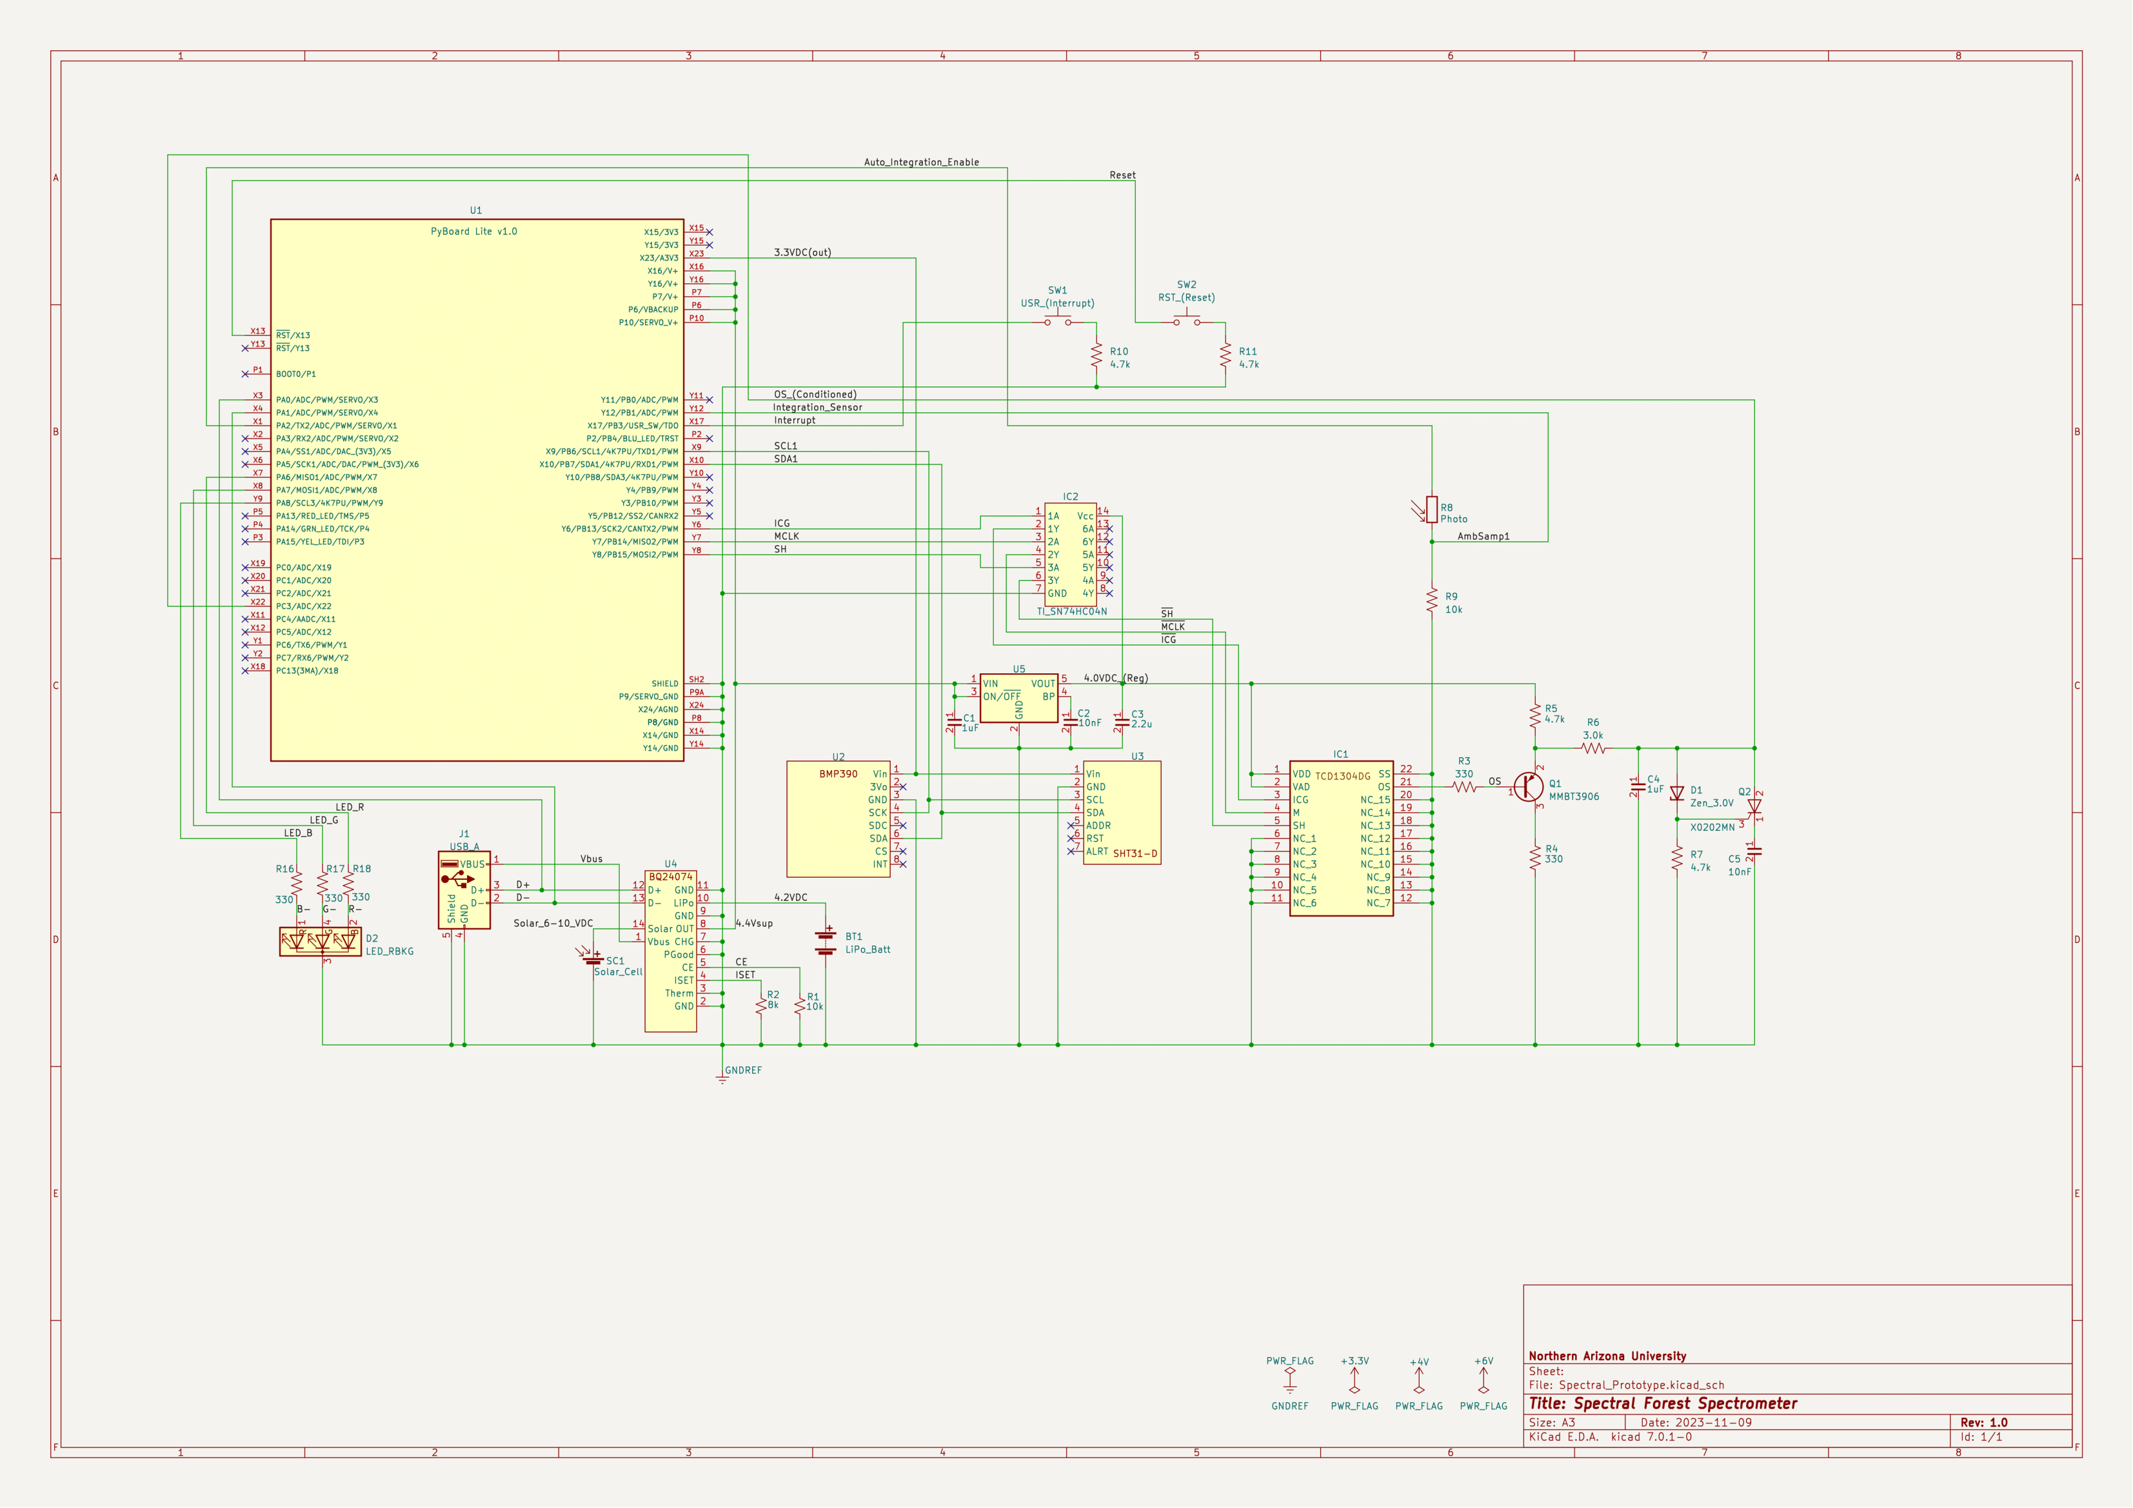The above schematic shows the wiring and pinout of the PyBoard microcontroller, and the components hooked up to it. The system operates off a regulated 4.0VDC which is used to power the TCD1304DG linear array, the amplifier hooked up to the linear array’s output (so that the output signal is large enough to interpret), and the TI_SN74HC04N inverter used to invert the input signals for the linear array. Data from the Toshiba chip is transferred to the PyBoard and stored within a mounted storage device.
Using the data from the linear array, it is possible to make deductions based off the spectral wavelength responses recorded of the general wellbeing of the plant life within the forest and can be assessed under whichever conditions each data sample was taken at based upon readings from the environmental sensors within the system, the BMP390 and SHT31-D chips.
Below is the Bill of Materials used with the above schematic, including part numbers and manufacturers.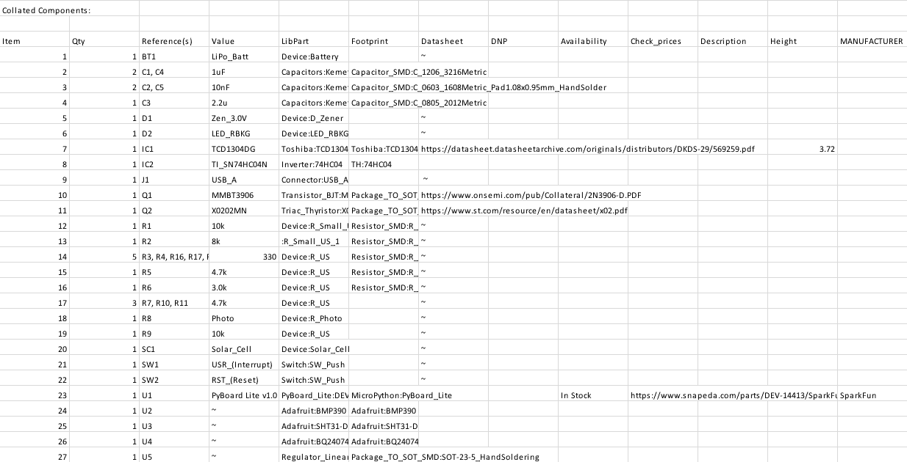
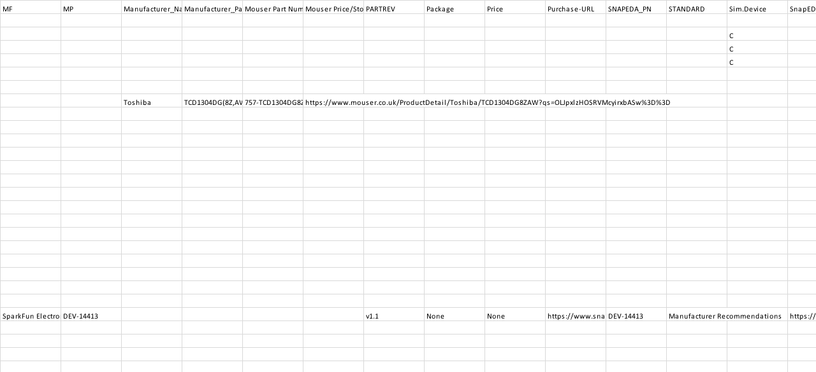

Project Management

Work Breakdown Structure
Our work breakdown structure includes details such as the activities, descriptions, deliverables, durations, due dates, assigned personnel, resources, and milestones. We also documented some prerequisite tasks before starting a new one. Some of the milestones included are hardware design prototype, multidisciplinary integration, evaluation, poster submission, and undergraduate presentations. We have determined that programming and hardware design will take the longest duration followed by testing and calibration. Currently we are slightly ahead of schedule, which allows us extra time for the final design of the printed circuit board as well as testing.

Gantt Chart
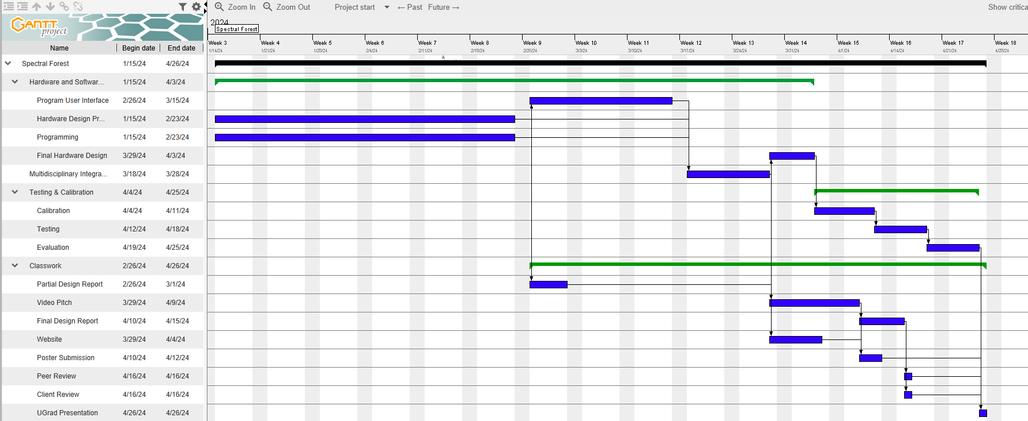

The Gantt chart indicates the activities that need to be completed as well as the activities that depend on others. As we can see on the chart, hardware prototype can be done at the same time as the programming. The programming and hardware prototype need to be completed before we can start on the user interface as well as get the partial report. Once the user interface is complete, we can start the multidisciplinary integration which is where we combine the mechanical structure and the electronics. Once the integration is completed, we are then able to design the final hardware design, video pitch, and update the website. Once the final hardware design is complete, we can start the testing and calibration part of the project, which involves testing the final design and calibrating the light spectrum on the TCD1304DG. Once testing and calibration are complete, we will be able to start the evaluation to understand if there are any necessary changes to the program. Once the evaluation is complete, we will be able to present the work at UGrad.

PERT Chart
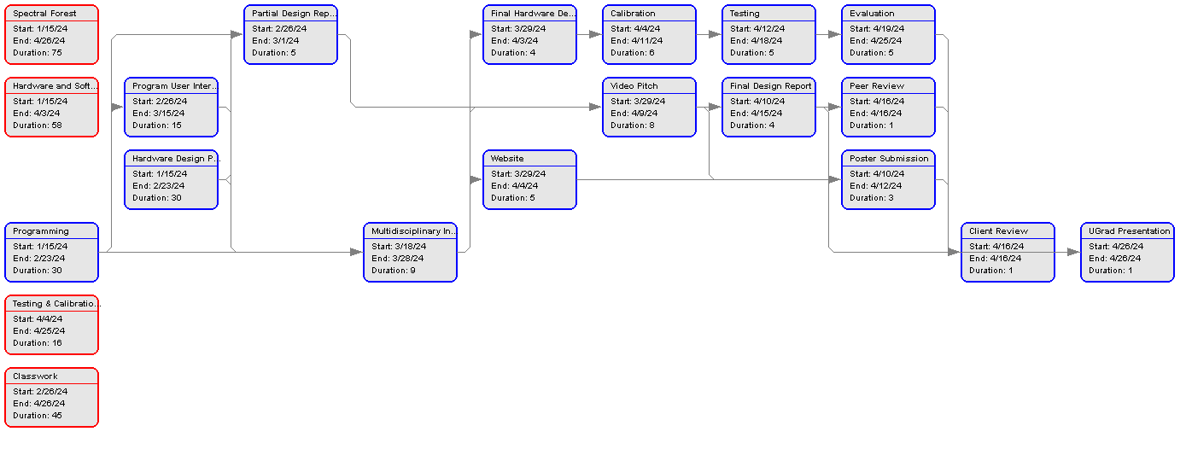
The PERT chart is an illustration of the Gantt chart description above. It focuses on what tasks need to be completed before other tasks can be started. It also tells us the expected duration of each task. It will be essential to stay on track to complete the project before the April 26 deadline. For example, once the partial report has been submitted in Canvas we can begin updating the website.

Testing
The construction of the main script was completed in a modular fashion. Each section of the code was developed individually and then tested. Once each section of code had been validated it was added into the compilation of modules that constitutes the main program loop. During this process, sections of the code that were working independently did not always work as intended when fit within the main loop of the program. Generally, the solution to code that was working independently, that fails in the main loop, just comes down to placement within the code. Some variables that store sensor values are prime examples of variables that need to be placed correctly so they refresh during consecutive readings. Another hard-won realization is that the only way to successfully write and save data is to perform a hard reset via the machine.reset() command. A simple solution that caused several weeks of confusion and troubleshooting.
The table below shows the ten accelerometer readings stored on the micro-SD card.
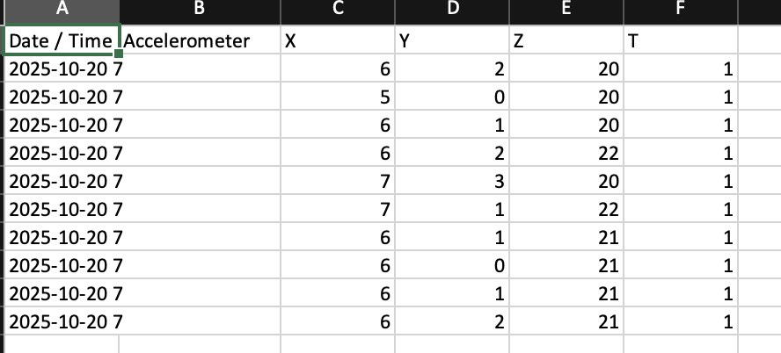

The table below shows the Temperature, Percent Humidity, and Integration Level
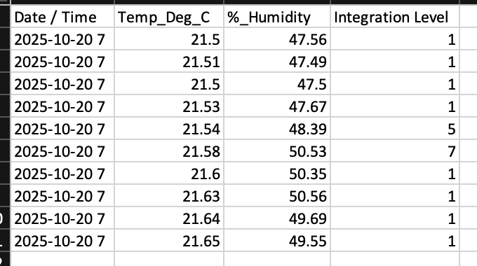

A good amount of time was spent formatting data to correctly store in the pre-allocated data files. The main goal of the spectrometer is to store spectral data, but along with these data points the device will also store environmental conditions collected from within the optical compartment. Accelerometer data is also collected to provide orientation information. The spectrometer will be deployed via drone, and the accelerometer will give a basis for the angle that the exposure was taken at. The CSV writing function was written from scratch. This is due to the lack of a preexisting library compatible with Micropython.
Initially testing the write and save functionality was done to the onboard memory in the ARM processor, but ultimately a 128GB micro-SD card will be used as the mass storage device. Initial attempts to save to the micro-SD card were unsuccessful. This held true for a while, and ultimately several micro-SD cards were used until one of them eventually worked. It was eventually determined that the formatting was the issue. For the micropython driven PyBoard, the micro-SD card must be formatted in the universal FAT type formatting.
A large amount of testing was centered around trying to break the main loop. Exception handling for typos or incorrect entries will not crash the program. The program will stay within while loops until a successful entry has been entered. The script was also tested on different devices and different operating systems. The program runs without issue on MacOS and Linux. Currently no tests have been conducted on Windows machines. The requirements for this project specified Linux as the preferred operating system, which is also the platform used for programming the PyBoard and all of the foundational tests.
An auto integration function has been built in as an option to dynamically control the integration exposure time of the Toshiba TCD. Tests were completed to prove the concept as a viable solution to optimizing exposure times during varying conditions. Further testing must be done in situ to dial in the nine preset exposure times. We can ballpark these settings now, but we will need the full optical assembly to be completed to find the true nominal settings for the opto-electrical system.

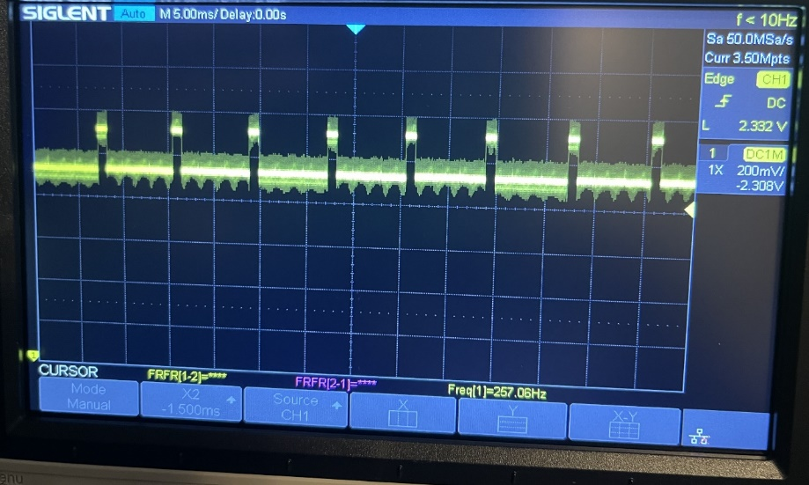
The image shown to the left is an output signal on the oscilloscope. The output signal shows dummy pixels.

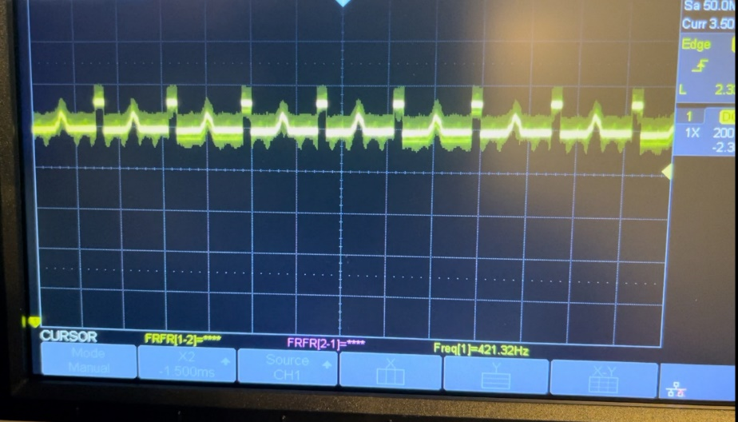
The output signal shows a peak which indicates a value being generated. The peak is created by blocking light to the TCD1304DG.

Conclusion
The hardware prototype and programming are about complete and the next steps that the team needs to focus on are the user interface, integration, final hardware design, testing, calibration, and final evaluation of the project. We are expecting to get revision one of our custom designed PCB ordered and manufactured by March 25, 2024. The first revision of our custom PCB is expected to have some issues that need to be worked out. Ordering early in the process will allow us to have time to fix any issues and order the final revision of the PCB. We are expecting to start working closely with the mechanical engineering team to get the structure, optics, and electronics working together. This will be done as soon as the PCB is manufactured. Our expected start date for the integration is March 25. Once the integration has been completed, our team will focus on the calibration and testing of the system. This part of the project is expected to begin on Aril 7. This should be enough time to make changes to the PCB if needed. The project is progressing well, and we should have enough time to finish the design before the deadline.

References
[1] Curious Scientist, “TCD1304 linear CCD - driving the CCD,” Curious Scientist, https://curiousscientist.tech/blog/tcd1304-linear-ccd-driving-the-ccd (accessed Mar. 1, 2024).

